Subject Details

Academic Year: | 2025-2026 | Subject Code: | 05MC0105
Course: | M.C.A. | Subject Name: | RDBMS
Semester: | 1 | Division: | A

Course Work - Extended Case Study Title:
" Design and Implementation of a Bus Management System Using SQL & PL/SQL"

Group Details:
Sr. No. | Roll No | Student Name | Signature of  Student
1 | 92500584012 | Nevil Aghera
2 | 92500584026 | Jenil Kothiya
3 | 92500584027 | Avesh Mahamdhanif Kadari

Submission Details:
Subject Faculty | Meghna Bhatt
Date
Signature

Assessment & Grading

Sr.  No. | Roll No | Student  Name | R1 | R2 | R3 | R4 | R5 | R6 | Total (out of 50) | Grade
1 | 92500584012 | Nevil Jayeshbhai Aghera
2 | 92500584026 | Jenil dipakbhai Kothiya
3 | 92500584127 | Avesh  Mahmadhanif  Kadari

Course Objectives:
- To introduce core database concepts and enable students to perform operations using SQL and PL/SQL.
- To develop an understanding of database design principles and normalization techniques for creating efficient relational schemas.
- To familiarize students with transaction management and database security mechanisms to ensure data integrity and protection.
- To impart knowledge of PL/SQL programming constructs such as procedures, functions, and triggers for implementing business logic in databases.
- To build competence in writing and evaluating SQL queries for data definition, manipulation, control, and retrieval in relational database systems.

Course Outcomes:
- Implement core database concepts through SQL, PL/SQL operations.
- Apply database design principles and normalization process to develop efficient relational schemas.
- Use transaction processing and security mechanisms for data integrity and security.
- Analyze PL/SQL blocks, procedures, functions, and triggers to implement business logic within databases.
- Evaluate SQL queries for data definition, manipulation, control, and retrieval to interact with relational databases.
Coursework Objectives:
- To apply core database concepts by designing and implementing an Bus Management System using SQL and PL/SQL.
- To construct normalized relational schemas that ensure accuracy, efficiency, and consistency of stored data such as books, users, orders, and reviews.
- To demonstrate transaction management and security mechanisms to maintain reliable and secure operations for book purchasing, wish lists, and payments.
- To implement business logic for store operations through PL/SQL constructs such as procedures, functions, triggers, and packages.
- To practice writing, optimizing, and evaluating SQL queries for defining, manipulating, and retrieving data effectively across multiple tables.

Coursework Outcomes:
- Implement core database concepts by performing SQL and PL/SQL operations in an Bus Management System environment.
- Apply database design principles and normalization techniques to create efficient and consistent relational schemas for store management.
- Utilize transaction management and security features to ensure data integrity, reliability, and protection during online operations.
- Analyze and develop PL/SQL constructs (procedures, functions, triggers, and packages) to automate tasks such as order handling and stock updates.
- Evaluate and optimize SQL queries for data definition, manipulation, control, and retrieval within the relational database system of the Bus Management System.

Coursework Outcomes and Course Outcomes (CWO–CO) Mapping Table:

Coursework Outcomes  (CWO) | Course Outcomes (CO) | Level of Correlation
CWO1: Design and implement a relational schema for an  Bus Management System applying normalization principles. | CO2: Apply database design principles and normalization process to develop efficient relational schemas. | 3 (High)
CWO2: Develop and test SQL queries for insertion, deletion, updating, and retrieval of bus and Route records. | CO1: Implement core database concepts through SQL, PL/SQL operations.  CO5: Evaluate SQL queries for data definition, manipulation, control, and retrieval to interact with relational databases. | 3 (High)
CWO3: Apply transaction management and security constraints to maintain reliable and secure database operations for online orders and payments. | CO3: Use transaction processing and security mechanisms for data integrity and security. | 3 (High)
CWO4: Construct PL/SQL blocks, procedures, functions, and triggers to enforce business rules and automate store operations such as stock updates and order billing. | CO1: Implement core database concepts through SQL, PL/SQL operations.  CO4: Analyze PL/SQL blocks, procedures, functions, and triggers to implement business logic within databases. | 2 (Medium)
CWO5: Demonstrate integration of SQL and PL/SQL to develop a functional and efficient Bus Management System on Oracle RDBMS. | CO1: Implement core database concepts through SQL, PL/SQL operations.  CO5: Evaluate SQL queries for data definition, manipulation, control, and retrieval to interact with relational databases. | 3 (High)

Gaps & Topics covered beyond the syllabus to achieve Pos

Sr. No. | Description | Topic to be  Covered | Description  References | NBA Program Outcome | Level of Correlation | Justification
1 | Packages | Combining and calling various object through  Packages | Packages  https://docs.oracle. com/en/database/o racle/oracledatabase/23/lnpls/p lsql-packages.html | PO1: Demonstrate strong technical knowledge and skills to design, develop, and implement efficient software solutions using modern computing tools and methodologies. | 3 (High) | Packages directly apply OOP concepts to design modular, reusable, and efficient software solutions.
 |  |  |  | PO2: Analyse complex computing problems and devise optimized solutions through critical thinking and systematic approaches. | 2 (Medium) | Packages help organize classes  logically,  simplifying the analysis and management of complex systems.
 |  |  |  | PO3: Create innovative and sustainable IT systems that meet user needs while incorporating emerging technologies and creative problem-solving. | 1 (Low) | Packages support scalability and maintainability,  which are essential for sustainable IT systems.

References for topics covered beyond the syllabus:
- “SQL, PL/SQL the programming Language of Oracle”, Ivan Byross, BPB Publication, 4th Edition.
- “Oracle Database 11g: The Complete Reference”, Kevin Loney, Oracle Press.
- GeeksforGeeks – PL/SQL Triggers Tutorial.
- Oracle Database Documentation – PL/SQL Packages and Procedures.

Requirements Analysis:
Functional Requirements:
  - User Management: Store user details and roles (customer/admin).
  - Book Management: Maintain book details such as title, author, price, stock, and category.
  - Category Management: Organize books under defined categories for easy access.
  - Order Management: Handle orders, payments, and delivery statuses.
  - Wishlist Management: Allow users to save books for future purchase.
  - Review & Rating: Collect and display customer reviews and ratings.
  - Cart Management: Manage selected books and calculate total price before checkout.
  - Accessories Management: Maintain Accessories details such as Quantity, price, stock, and category.
  - Admin Dashboard: Enable admins to monitor and manage books, users, and orders.

Database Dictionary:

- BookingMasrer
Field name | Data type | Constraint | Description

Entity Relationship Diagram (ERD)
E–R Diagram for the given Online Book Store schema that includes:
  - Composite attribute
  - Multivalued attribute
  - Derived attribute
  - Mapping cardinality limits

Key Enhancements for ER Model To satisfy your requirements:
  - Composite Attribute → User Name (split into FirstName + LastName).
  - Multivalued Attribute → Book Genre (since a book can belong to multiple genres).
  - Derived Attribute → TotalAmount (derived from the sum of quantity × price in each Order_Item record)

Entities and Attributes
  - User
    - ID (PK)
    - Name (Composite: FirstName, LastName)
    - Email
    - Password
    - Role
    - CreatedAt

  - Admin
    - AdminID (PK)
    - Name
    - Password
    - CreatedAt

  - Category
    - CategoryID (PK)
    - Name
    - CoverImage

- Book
    - BookID (PK)
    - Title
    - Author
    - Description
    - Price
    - Stock
    - category_name
    - CoverImage
    - Created_at
    - (FK → CategoryID)

- Order
    - OrderID (PK)
    - OrderDate
    - Status
    - TotalAmount (Derived)
    - (FK → UserID)

- Order_Item
    - Quantity
    - Price
    - (FK → OrderID
    - (FK → BookID)

- Wishlist
    - WishlistID (PK)
    - (FK → UserID)
    - (FK → BookID)
    - CreatedAt

- Cart
    - Quantity
    - Created_at
    - (FK → UserID, BookID)
- Accessories
      - AccessoryID (PK)
      - Name
      - Description
      - Price
      - Stock
      - Image
      - Quentity

- Shop_Exc
      - ShopID (PK)
      - Title
      - Description
      - Price
      - Image
      - Quantity
      - CreatedAt

- Contact_Messages
      - MessageID (PK)
      - Name
      - Email
      - Subject
      - Message
      - CreatedAt

Relationships with Cardinalities

  - User — Buy — Book o Relationship: A User can buy many Books.
o Cardinality:
        - User → Book → 1 : M
        - One User can buy many Books; a Book can be bought by many Users (M:N).

  - User — has — Order o Relationship: A User can place multiple Orders.
o Cardinality:
▪ User → Order → 1 : M

  - Order — has — Order_Item o Relationship: An Order contains multiple Order Items.
o Cardinality:
▪ Order → Order_Item → 1 : M

  - Order — has — User o Relationship: Each Order belongs to one User.
o Cardinality:
▪ Order → User → M : 1

  - User — has — Contact_Message o Relationship: A User can send multiple Contact Messages.
o Cardinality:
▪ User → Contact_Message → 1 : M

  - Category — has — Book o Relationship: A Category contains multiple Books.
o Cardinality:
▪ Category → Book → 1 : M

  - User — has — Cart o Relationship: A User can have multiple items in their Cart.
o Cardinality:
▪ User → Cart → 1 : M

  - User — has — Wishlist o Relationship: A User can have multiple items in their Wishlist.
o Cardinality:
▪ User → Wishlist → 1 : M

  - Admin — Manage — Book o Relationship: Admin manages multiple Books.
o Cardinality:
▪ Admin → Book → 1 : M

  - Admin — Manage — Accessories o Relationship: Admin manages multiple Accessories.
o Cardinality:
▪ Admin → Accessories → 1 : M

  - Admin — Manage — Shop_Exc o Relationship: Admin manages multiple Shop_Excs.
o Cardinality:
▪ Admin → Shop_Exc → 1 : M

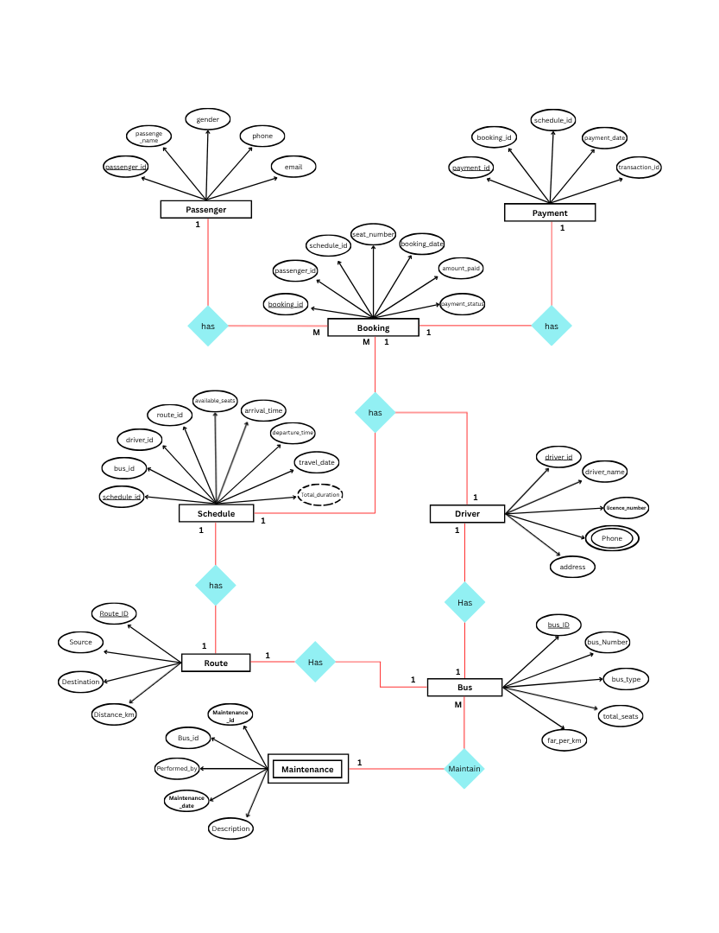
Diagram:

